9.101: a)
gives a quadratic in . The positive solution is
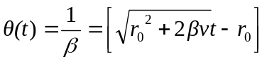.
(The negative solution would be going backwards, to values of r smaller than .)

c) Differentiating,
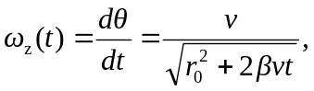

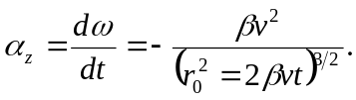

The angular acceleration 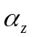 is not constant. d) 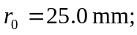 It is crucial that is measured in radians, so The total angle turned in 74.0 min = 4440 s is

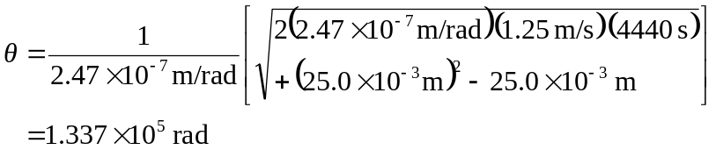

which is 2.13 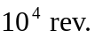

e)
